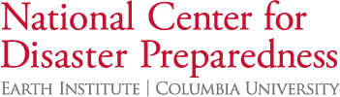

Activities

What is on your radar?

Example:

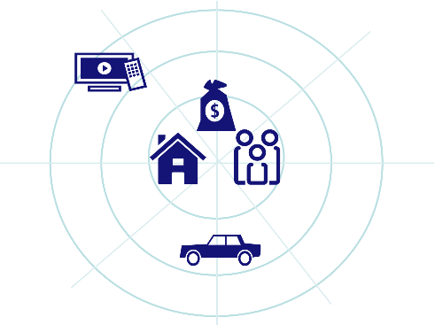

Stakeholder Map

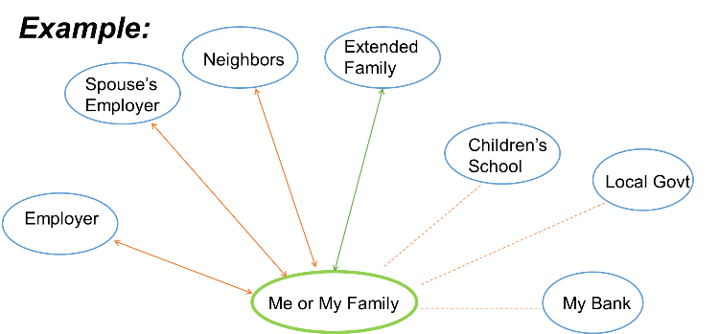

: One – Way
: Two – Way Relationship

Additional Resources:

NCDP, Columbia & USTTI 2019

Project OWL:
https://www.youtube.com/watch?v=d7aAdk87Yv8
https://www.bloomberg.com/news/articles/2019-05-06/ibm-backed-project-creates-wi-fi-network-for-natural-disasters
Hazard Assessment of Large Earthquakes and Tsunamis in the Mexican Pacific Coast for Disaster Mitigation
https://www.jst.go.jp/global/english/kadai/h2710_mexico.html
Ready Business Mentoring Guide:
https://www.fema.gov/media-library-data/1392217307183-56ed30008abd809cac1a3027488a4c24/2014_business_user_guide.pdf
2019 Hurricane Season Preparedness Tools
https://ncdp.columbia.edu/microsite-page/hurricane-season-2019/preparedness-tools/
The Resilient Children/Resilient Communities Toolbox
https://rcrctoolbox.org
NCDP LMS - eLearning Coming Soon
https://ncdpcourses.crlctraining.org/Default.asp?
Emergency Financial First Aid Kit
https://www.fema.gov/media-library/assets/documents/96123

